**Day 1 – Transformations**

There are many different ways to move a figure on the coordinate plane. Some movements keep the figure the same size and some may make the figure bigger or smaller. These “movements” are called transformations. **Transformations** are the mapping or movement of all the points in a figure on the coordinate plane.

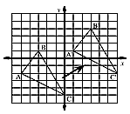

When a figure is the original figure, it is called the **pre-image**. The prefix “pre” means ________________. In the above picture, we would label the points as A, B, and C.

When a figure has been transformed, it is called the **image**. We would label the new points as A’, B’, and C’. We would say that points A, B, and C have been mapped to the new points A’, B’, and C’

**Exploring Translations**

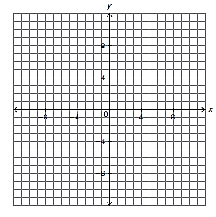

A. Graph triangle ABC by plotting points A(8, 10), B(1, 2), and C(8, 2).

B. Translate triangle ABC 10 units to the left to form triangle A’B’C’ and write new coordinates.

C. Translate triangle ABC 12 units down to form triangle A’’B’’C’’ and write new coordinates.

|  |  |  |
| --- | --- | --- |
| **Coordinates of Triangle**  **ABC** | **Coordinates of Triangle**  **A’B’C’** | **Coordinates of Triangle**  **A’’B’’C’’** |
| A (8, 10) |  |  |
| B (1, 2) |  |  |
| C(8, 2)) |  |  |

**Observation:** Did the figures change

size or shape after each transformation?

You observed that your four triangles maintained the same shape and size. When a figure keeps the same size and shape, it is called a **rigid transformation.**

With your experiment, you were performing a translation. A **translation** is a slide that maps all points of a figure the same distance in the same direction. A translation can slide a figure horizontally, vertically, or both.

**Rule for Translations**: **(x, y) 🡪 (x + a, y + b)**

a 🡪 left or right translations (horizontally)

b 🡪 up or down translations (vertically)

**Practice with Translations**

**Practice:**

a. has vertices A(1, 2), B(3, 6), and C(9, 7). b. has vertices X(-5, 1), Y(-7, -4), and Z(-2, -4).

What are the vertices after the triangle is What are the vertices after the triangle is

translated 4 units left? translated 1 unit right and 6 units up?

Rule: Rule:

New Points: New Points: 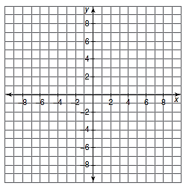

c. Name the rule for the given figures:

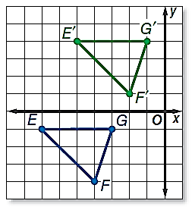 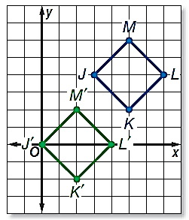

d. The pre-image of is shown below. The image of is  with L’(1, -2), M’(3, -4), and N’(6, -2)**.** What is a rule that describes the translation?

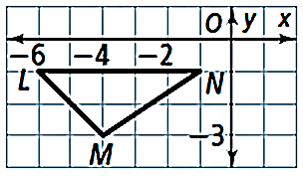

**Reflections**

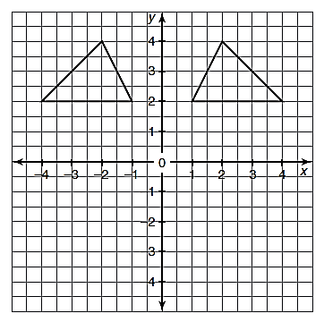1. Look at the two triangles in the figure. . Do you think they are congruent?

Figures that are mirror images of each other are called reflections. A **reflection** is a transformation that “flips” a figure over a reflection line. A **reflection line** is a line that acts as a mirror so that corresponding points are the same distance from the mirror. Reflections maintain shape and size; they are our second type of rigid transformation.

2. What do you think the reflection line is in the diagram?

3. Draw a triangle that would be a reflection over the x-axis.

4. What do you notice about the reflected triangles’ points in relation to the pre-image?

**Reflection over y-axis**

Reflect parallelogram ABCD over the y-axis using reflection lines. Record the points in the table.

|  |  |  |
| --- | --- | --- |
|  | **Pre-Image** | **Image** |
| **A** |  |  |
| **B** |  |  |
| **C** |  |  |
| **D** |  |  |
| **Rule** | (x, y) |  |

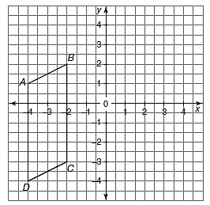

**Reflection over x-axis**

Reflect parallelogram ABCD over the x-axis using reflection lines. Record the points in the table

|  |  |  |
| --- | --- | --- |
|  | **Pre-Image** | **Image** |
| **A** |  |  |
| **B** |  |  |
| **C** |  |  |
| **D** |  |  |
| **Rule** | (x, y) |  |

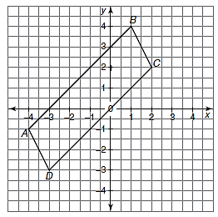

**Reflection over y = x**

Reflect the triangle over the y = x using reflection lines. Record the points in the table

|  |  |  |
| --- | --- | --- |
|  | **Pre-Image** | **Image** |
| **A** |  |  |
| **B** |  |  |
| **C** |  |  |
| **Rule** | (x, y) |  |

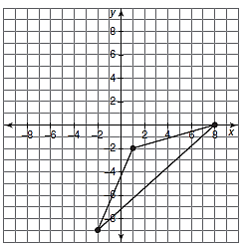

**Reflection over y = -x**

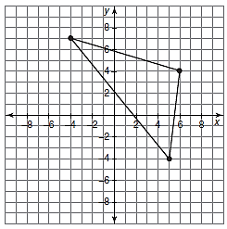Reflect triangle ABC over the y = -x using reflection lines. Record the points in the table

|  |  |  |
| --- | --- | --- |
|  | **Pre-Image** | **Image** |
| **A** |  |  |
| **B** |  |  |
| **C** |  |  |
| **Rule** | (x, y) |  |

**Reflection over Horizontal and Vertical Lines**

Reflect over x = -1 Reflect over y = 2

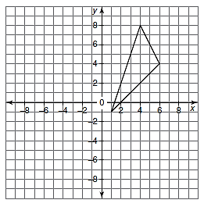 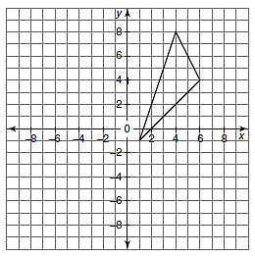

**Practice with Reflections**

Given triangle MNP with vertices of M(1, 2), N(1, 4), and P(3, 3), reflect across the following lines of reflection:

**x-axis y-axis y = x y = -x**

**(x, y)🡪 (x, y)🡪 (x, y)🡪 (x, y)🡪**

M(1, 2) 🡪 M(1, 2) 🡪 M(1, 2) 🡪 M(1, 2) 🡪

N(1, 4)🡪 N(1, 4)🡪 N(1, 4)🡪 N(1, 4)🡪

P(3, 3)🡪 P(3, 3)🡪 P(3, 3)🡪 P(3, 3)🡪

**Day 2 – Rotations, Symmetry, and Multiple Transformations**

A **rotation** is a circular movement around a central point that stays fixed and everything else moves around that point in a circle. A rotation maintains size and shape; therefore, it is our third type of rigid transformation.

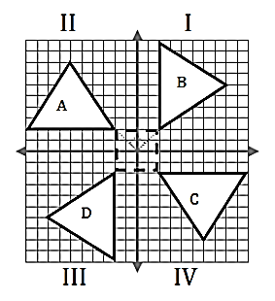

When we rotate our figures around a fixed point, we classify our rotation by direction and degree of rotation.

**Degrees of Rotation Direction of Rotation**



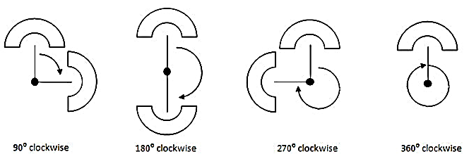

It is important to understand that some rotations are the same depending on the degree and direction of the rotation. Most of the time, rotations are given using counterclockwise direction. Here are equivalent rotations:

**90****Counterclockwise = 270****Clockwise 90****Clockwise = 270****Counterclockwise**

**180****Counterclockwise = 180****Clockwise**

**Rules for Rotations**

|  |  |  |
| --- | --- | --- |
| **90CCW / 270CW** | **180CCW / 180CW** | **90CW/270CCW** |
| (x, y) 🡪 (-y, x) | (x, y) 🡪 (-x, -y) | (x, y) 🡪(y, -x) |
|  |  |  |

**Practice with Rotations**

a. Rotate 90**** bb. Rotate 180. Rotate 180**** CCW

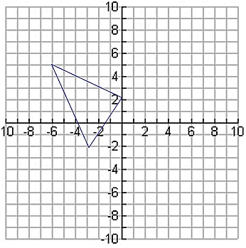 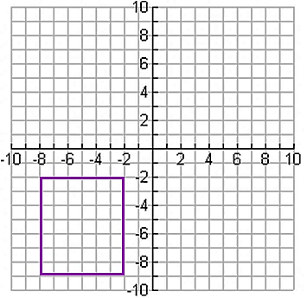

The line segment with endpoints (7, -8) and (-3, -5) are rotated 90****CW. What are its new endpoints?

c. Rotate 90****CW d.

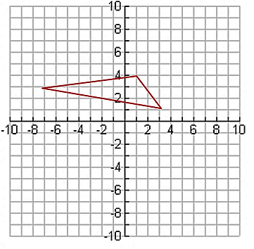

e. Describe the rotations:

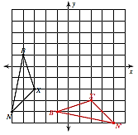 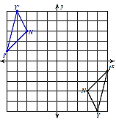

**Rotational Symmetry**

A figure has **rotational symmetry** If there is a center point around which the object is turned a certain number of degrees and the object looks the same. The degree of rotational symmetry that an object has is called its **order.** The order of rotational symmetry that an object has is the number of times that it fits onto itself during a full rotation of 360 degrees. To determine the **angle of rotation**, divide 360 degrees by its order.

**Example:** Determine the order and angle of rotation:



**Practice:** For the following figures, name the order and degrees of rotation:

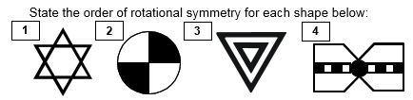

**Combined Transformations**

**Practice:** Describe that transformations that occurred from the pre-image to each image (in order).

A. B.

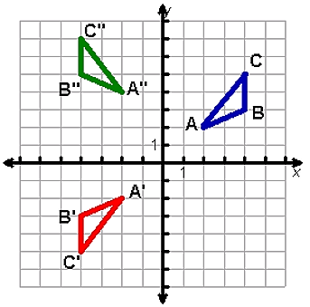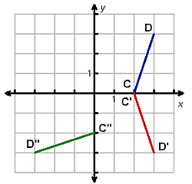

C. D.

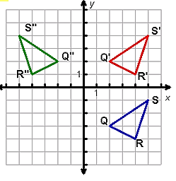

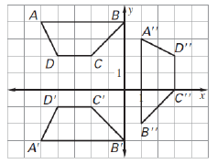

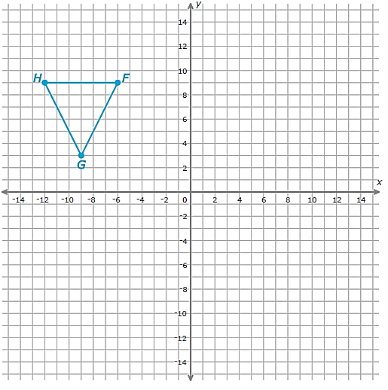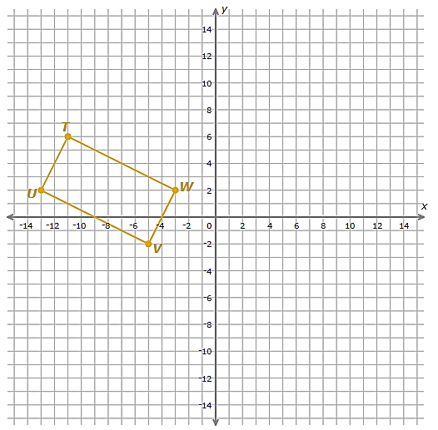

**Perform the following transformations:**

a. Rotation 180 CW around the origin:

b. Reflection across the y-axis:

**Perform the following transformations:**

a. Translation (x, y) 🡪 (x + 16, y):

b. Reflection across y = -4:

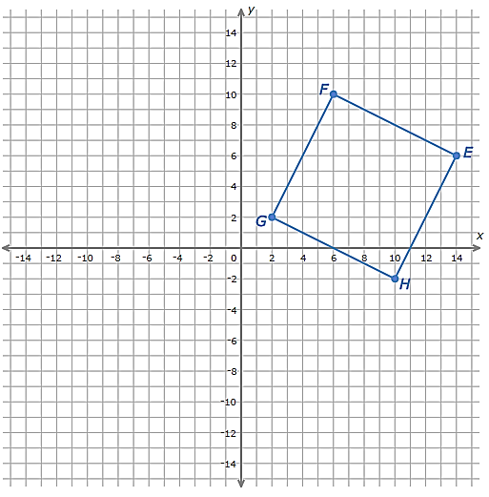 **Summary of Transformation Rules**

**Perform the following transformations:**

a. Rotation 90 CCW around the origin:

b. Translation (x, y) 🡪 (x + 6, y – 16)

|  |  |  |
| --- | --- | --- |
| **Transformation** | **Rules** | **Examples** |
| Translations  “*slide”* | (x, y) 🡪 (x + a, y + b)  a: horizontal slide (+ right, - left)  b: vertical slide (+ up, - down) |  |
| Reflections  *“flip”* | x-axis: (x, y) 🡪 (x, -y)  y-axis: (x, y)🡪(-x, y)  y = x: (x, y) 🡪 (y, x)  y = -x: (x, y) 🡪 (-y, -x) |  |
| Rotations  “*turn”* | 90CW = 270CCW: (x, y)🡪 (y, -x)  180CW = 180CCW : (x, y) 🡪 (-x, -y)  90 CCW = 270CW: (x, y) 🡪 (-y, x) |  |