Learning Card # ______ | Name:
When writing a ____________, it is important  to _______________ each logical step with a  _______________. |  | 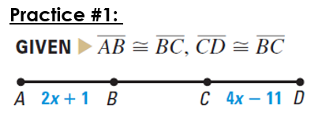  Prove: x = 6
Algebraic Proofs

Learning Card # ______ | Name:
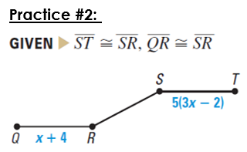  Prove: x = 1 |  | 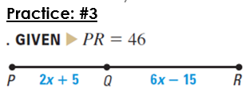  Prove: x = 7
Algebraic Proofs (part 2)

Learning Card # ______ | Name:
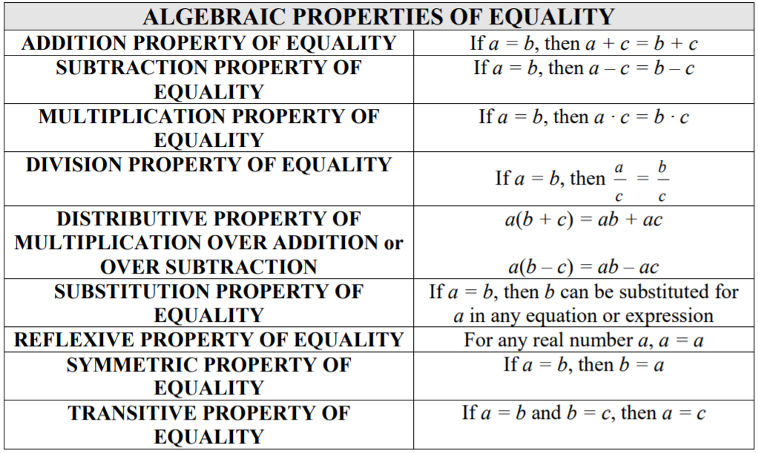
Common Proof Reasons

