Learning Card # ______ | Name:
A line, line segment, or ray that divides the line segment into _____ _________________line segments.  Similar to a _______________.  Segment bisector drawing: |  | Solve:  Find $\overline{AB}$ and $\overline{CB}$  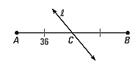
Draw:  $\overline{AB}$ is a segment bisector of $\overline{XY}$.  $\overline{AY}=15$  $$\overline{XY}=4y+10$$  Solve for y. |  | Explain:  Is $\overline{PC}$ a segment bisector?  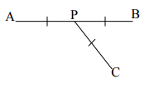
Segment Bisector

