Learning Card # ______ | Name:
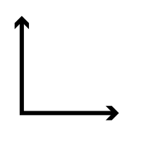  Right angles measure exactly _______ |  | 2 or more angles that make up a right angle  are called _______________________  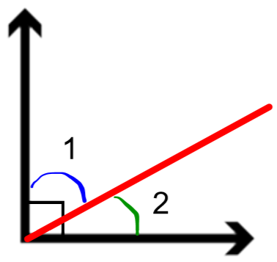
Straight angles measure exactly ________ |  | 2 or more angles that make up a straight angle  are called _______________________  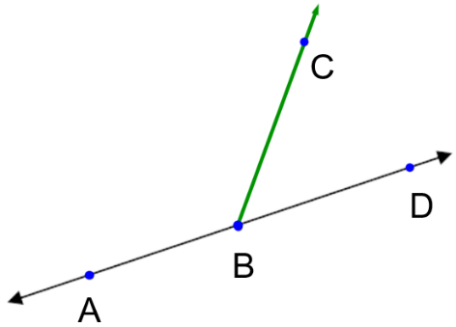
Right Angles and Straight Angles

