Learning Card # ______ | Name:
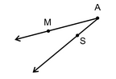 |  | If an angle sits alone, you can name it using only its vertex.  If an angle lies with other angles, you should name it using _____ letters, with the V_______ Point being the middle letter
Practice:  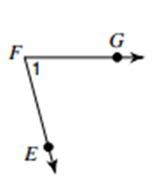  Name the angle in four ways: |  | Practice:  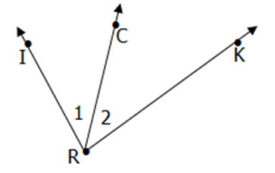  Name angle 1 as many ways as possible:
Naming Angles

