Learning Card # ______ | Name:
Linear Pair’s are very similar to: _______________  ________________  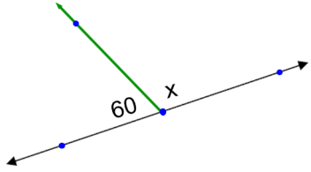  They make up a _____________ and equal _______ degrees. |  | Vertical Angles are angles created by  _______________________ lines  Vertical angles are _________________!  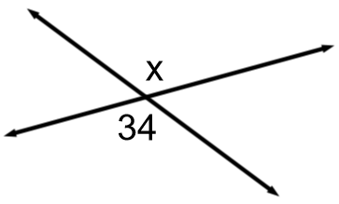
Practice:  Set up the linear pair and solve  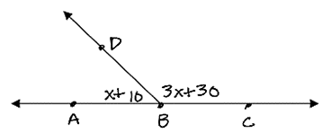 |  | Practice:  Set up the vertical angles and solve  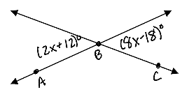
Linear Pairs and Vertical Angles

