Learning Card # ______ | Name:
Complementary Angles add up to _________  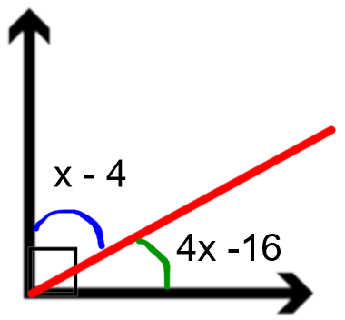  Set-Up Equation:  Solve:  Ex 1. The complement of $23°$ is _____________  Ex 2. The complement of $72°$ is _____________ |  | Supplementary Angles add up to ________________  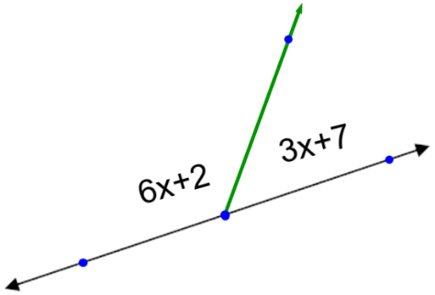  Set-Up Equation:  Solve:  Ex 1. The supplement of $145°$ is _____________  Ex 2. The supplement of $8°$ is ______________
Complementary and Supplementary Angles

