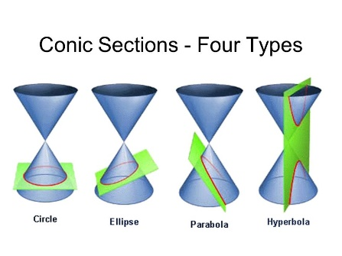
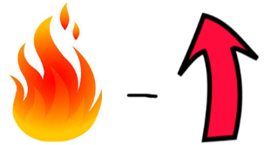
Keeper #7: General $→$ Standard Form (circles and ellipses)

Find the center and radius: Find the center, vertices, and co-vertices:
${\left(x-5\right)}^{2}+{\left(y+3\right)}^{2}=15$ $\frac{{\left(x+1\right)}^{2}}{4}+\frac{{\left(y-4\right)}^{2}}{25}=1$

State the coordinates of the foci:
$$\frac{{\left(x-3\right)}^{2}}{9}+{\left(y+6\right)}^{2}=1$$

Yesterday Recap
Vertices:
Co-vertices:

Foci:
Major axis:
Minor axis:
Eccentricity:

Completing the Square (remember??)
Ex. 1 $x^{2}+6x+ _____$ $+ y^{2}-8x+_____$ $=11+ _____$ $+ _____$

Ex. 2 $x^{2}-8x+_____$ $+ {5y}^{2}-30y=39$

Circles practice:
$x^{2}+y^{2}+6x-2y-6=0$ $x^{2}+y^{2}-8y+7=0$

$x^{2}+y^{2}+8x-4y+19=0$ $4x^{2}+4y^{2}+24x+12y-19=0$

Ellipses:
