Keeper #2: Multiplying Matrices

A = $\left[\begin{matrix}2 & 0 & 2 \\ 1 & 5 & -4\end{matrix}\right]$ B = $\left[\begin{matrix}-1 & 2 & 3 \\ 0 & 1 & 8\end{matrix}\right]$ C = $\left[\begin{matrix}3 & 3 & 5 \\ -4 & -5 & 0\end{matrix}\right]$

1. $A+B+C$ 2. $3C-2B$ 3. $4A+C$

4. See if you can figure out the pattern in order for this to make sense!
$\left[\begin{matrix}1 & 5 \\ 2 & 4\end{matrix}\right]$ x $\left[\begin{matrix}3 & 4 \\ 1 & 8\end{matrix}\right]$ = $\left[\begin{matrix}8 & 44 \\ 10 & 40\end{matrix}\right]$

To multiply an ___________ matrix by an _________ matrix, the ns must be the same, and the result is
an ____________ matrix.

State the resulting dimensions (if possible) if multiplying the following matrices:
a) $\left[3x2\right] x [2x1]$ b) $\left[4x2\right] x [2x3]$ c) $\left[2x2\right] x [3x2]$

Matrix B
Matrix A
$\left[\begin{matrix}a & b \\ c & d\end{matrix}\right]$ x $\left[\begin{matrix}e & f \\ g & h\end{matrix}\right]$ = =

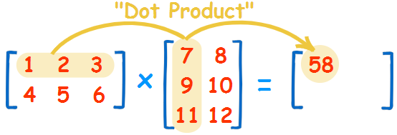

$\left[\begin{matrix}1 & 5 \\ 2 & 4\end{matrix}\right]$ x $\left[\begin{matrix}3 & 4 \\ 1 & 8\end{matrix}\right]$ = =

Ex. 1 Ex. 2
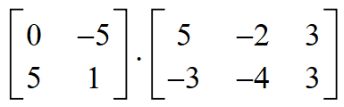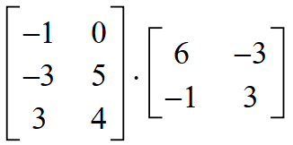

Ex. 3 Ex. 4
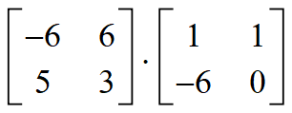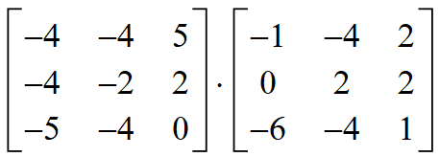

*Multiply any square matrix by $\left[\begin{matrix}1 & 0 \\ 0 & 1\end{matrix}\right]$ for a 2x2 or $\left[\begin{matrix}1 & 0 & 0 \\ 0 & 1 & 0 \\ 0 & 0 & 1\end{matrix}\right]$ for a 3x3 and see what happens

