CCGPS Geometry Unit 5: Circles Notes

**Intro to Circles and Arcs**

|  |  |  |
| --- | --- | --- |
| **Circle** |  |  |
| **Chord** |  |  |
| **Diameter** |  |  |
| **Radius** |  |  |
| **Secant** |  |  |
| **Tangent** |  |  |
| **Point of Tangency** |  |  |

**Circles have _______ degrees. Semicircles have _______ degrees.**

**Example:** Name all the parts of the circle:

**Radii:**



**Diameter:**



**Chords:**



**Secant:**



**Tangent:**



**Point of Tangency:**



**Practice:**

1. Name the following parts of the circle:

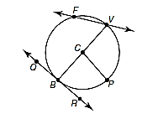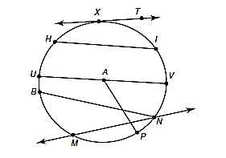

Circle: Point of Tangency:

Center: Tangent :

Diameter: Secant:

All Chords: All Radii:

2. Use the diagram to answer the following:



Circle: Point of Tangency:

Center: Tangent :

Diameter: Secant:

All Chords: All Radii:

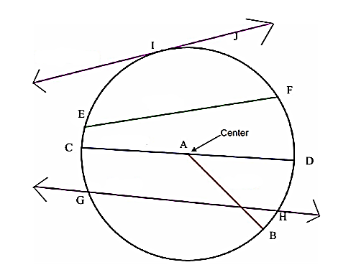**Example:** Name all the parts of the circle:

**Radii:**

**Diameter:**

**Chords:**

**Secant:**

**Tangent:**

**Point of Tangency:**

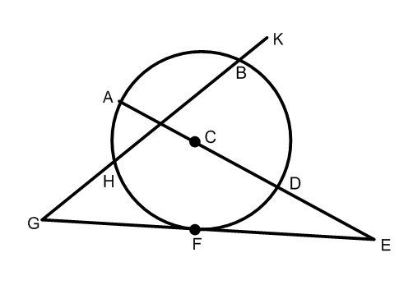**EXAMPLE:** Tell whether the line or segment is best described as a chord, a secant, a tangent, a diameter, or a radius—be specific!

a.  b. 

c.  d. 

e.  g. 

**Arcs & Central Angles**

An **arc** is an unbroken part of a circle consisting of two points called the endpoints and all the points on the circle between them.

|  |  |  |  |
| --- | --- | --- | --- |
| **Arc or Angle** | **Definition** | **Measure** | **Picture** |
| Minor Arc | An arc whose points are on or in the interior of a central angle. Minor arcs are less than 180 and only use two letters to name them. | The measure of a minor arc is equal to the measure of the central angle. |  |
| Major Arc | An arc whose endpoints are on or in the exterior of a central angle. Major arcs are between 180 and 360. Three letters are used to name a major arc. | The measure of a major arc is equal to 360 minus the measure of its central angle or minor arc. |  |
| Semicircle | An arc whose endpoints lie on a diameter. Semicircles are named using three letters. | The measure of a semicircle is 180. |  |
| Central Angle | An angle whose vertex is the center of the circle. | The measure of a central angle is equal to the measure of its minor arc. |  |
| **Name** | **Theorem** | **Hypothesis** | **Conclusion** |
| Arc Addition Postulate | The measure of an arc formed by two adjacent arcs is the sum of the measures of the two arcs. |  |  |

**Example:** Identify the following arcs are minor, major, or semicircle.

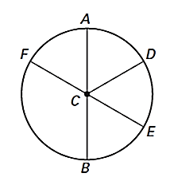

**Example:** Find the measure of the following:

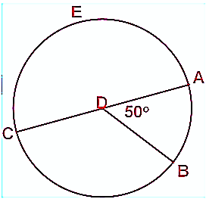****

**Example:** Find the measure of the following:

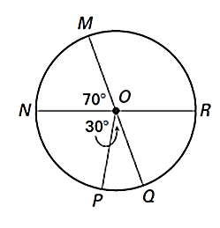****

**Example:** Find the value of x. Then find the measure of arc BC.

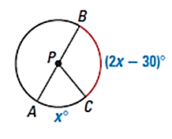

**Example:** Find the value of x. Then find the measure of all central angles and arcs.

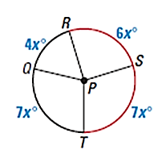

**Inscribed & Circumscribed Angles and Intercepted Arcs**

|  |  |  |  |
| --- | --- | --- | --- |
| **Name** | **Definition** | **Measure** | **Picture** |
| **Inscribed Angle** | An angle whose vertex is on a circle and whose sides contain chords of the circle | The measure of an inscribed angle is half the measure of its intercepted arc. |  |
| **Intercepted Arc** | An arc whose endpoints lie on the sides of an inscribed angle and all the points of the circle between them. | The measure of an intercepted arc is double the measure of the inscribed angle. |  |

**Example:** Find the measure of angle ABD. **Example:** Find the value of x and arc AD and arc ABD.

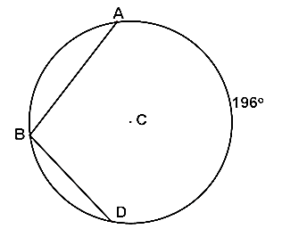 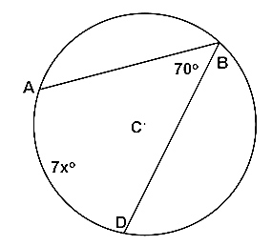

**Example:** Find the measure of arc AB and BC. **Example:** Find the measure of angle BAC.

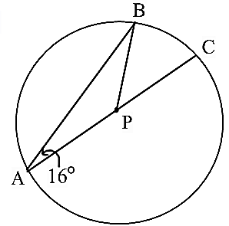 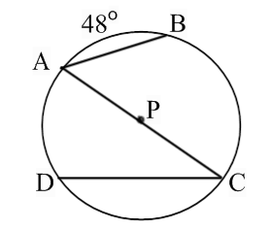

**Example:** Find the measure of angle JLM.

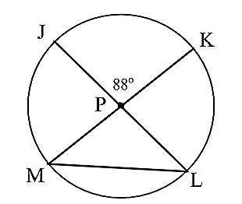

|  |  |  |  |
| --- | --- | --- | --- |
| **Name** | **Theorem** | **Hypothesis** | **Conclusion** |
| **Intercepted Arcs Corollary** | If inscribed angles of a circle intercept the same arc, then the angles are congruent |  |  |

**Example:** Find the measure of angle B. **Example:** Find the measure of angle G and arc IF.

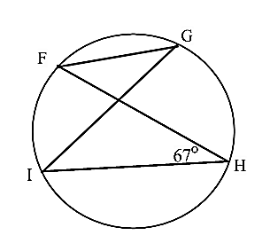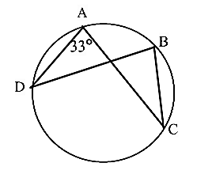

|  |  |  |  |
| --- | --- | --- | --- |
| **Name** | **Theorem** | **Hypothesis** | **Conclusion** |
| **Circumscribed Angle** | Angle formed by two rays that are each tangent to a circle. | The measure of a circumscribed angle is equal to 180 degrees minus the measure of the central angle that forms the intercepted arc. The rays are perpendicular to the radii of the circle. |  |

**Example:** What is the measure of angle A if angle D is 48 degrees?

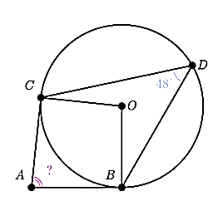

**Circumscribed and Inscribed Polygons**

|  |  |  |  |
| --- | --- | --- | --- |
| **Name** | **Theorem** | **Hypothesis** | **Conclusion** |
| **Inscribed Right Triangle Diameter Theorem** | If a triangle is inscribed in a circle such that one side of the triangle is a diameter of the circle, then the triangle is a right triangle. |  |  |
| **Converse of Right Triangle Diameter Theorem** | If a right triangle is inscribed in a circle, then the hypotenuse is a diameter of the circle. |  |  |

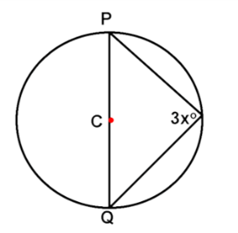**Example:** Find the measure of arc AED. **Example:** Find the value of x.

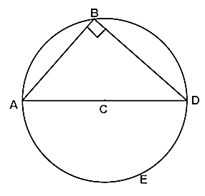

|  |  |  |  |
| --- | --- | --- | --- |
| **Name** | **Theorem** | **Hypothesis** | **Conclusion** |
| **Inscribed Polygons** | A polygon whose vertices lie on the circle. | Opposite angles are supplementary. |  |

**Example:** Find the value of x and y. **Example:** Find the value of x and y.

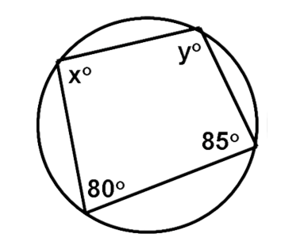 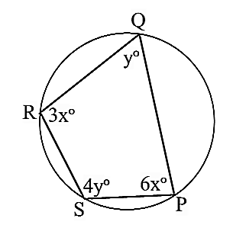

**Example:** Can this quadrilateral be inscribed inside a circle?

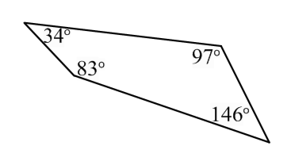

|  |  |  |  |
| --- | --- | --- | --- |
| **Name** | **Definition** | **Measure** | **Picture** |
| Circumcenter | When a triangle is inscribed in a circle, the center is called the circumcenter (formed by perpendicular bisectors). | The circumcenter is equidistant from the vertices of the triangle. |  |
| Inscribed Circle  Or  Circumscribed Triangle | Circle enclosed in a polygon, where every side of the polygon is tangent to the circle | NA |  |
| Incenter | When a circle is inscribed in a triangle, the center is called the incenter (formed by angle bisectors). | The incenter is equidistant from the sides of the triangle. |  |

**Angle Relationships (Vertex On, Inside & Outside)**

|  |  |  |  |
| --- | --- | --- | --- |
| **Name** | **Theorem** | **Hypothesis** | **Conclusion** |
| **Tangent Chord Theorem**  **(Vertex On)** | If a tangent and a chord intersect at a point on the circle, then the measure of each angle formed is one half the measure of its intercepted arc. |  |  |

**Example:** Find the measure of angle 1. **Example:** Find the measure of arc EFG.

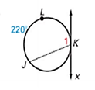 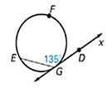

|  |  |  |  |
| --- | --- | --- | --- |
| **Name** | **Theorem** | **Hypothesis** | **Conclusion** |
| **Interior Angles of a Circle Theorem**  **(Vertex Inside)** | If two chords intersect **inside** the circle, then the measure of each angle is half the sum of the measures of the arcs intercepted by the angle and its vertical angle. |  |  |

**Example:** Find x and y. **Example:** Find the value of x.

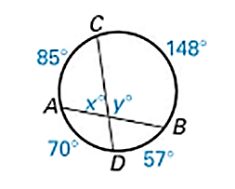 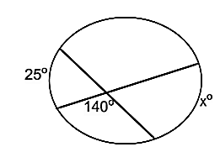

|  |  |  |  |
| --- | --- | --- | --- |
| **Name** | **Theorem** | **Hypothesis** | **Conclusion** |
| **Exterior Angles of a Circle Theorem**  **(Vertex Outside)** | If a tangent and a secant, two tangents, or two secants intersect **outside** the circle, then the measure of the angle formed is half the difference of the measures of the intercepted arcs. |  |  |

**Example:** Find the value of x. **Example:** Find the value of x.

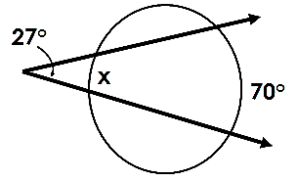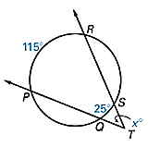

**Example:** Find the value of x.

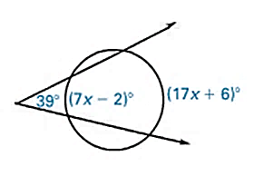

**Tangent and Chord Properties**

On Day 1, you learned that tangent lines intersect a circle in exactly one place. This leads to several theorems about tangent lines.

**Tangent Circles** are two coplanar circles that intersect at exactly one point. They may intersect internally or externally.

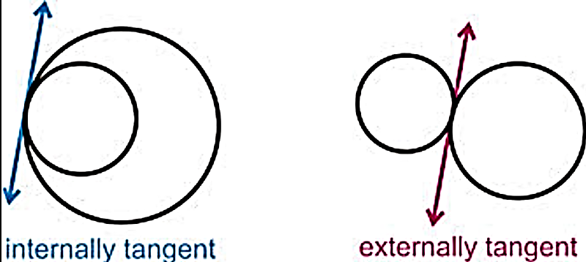

**Common Tangent Lines** are lines that are tangent to two circles.

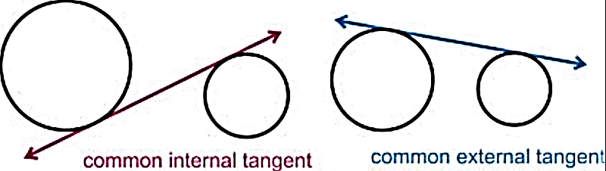

**Example:** Draw any common tangent lines.

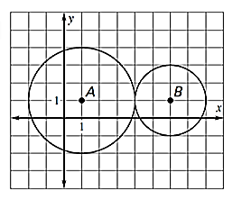

|  |  |  |  |
| --- | --- | --- | --- |
| **Name** | **Theorem** | **Hypothesis** | **Conclusion** |
| **Perpendicular Tangent Theorem** | If a line is tangent to a circle, then it is perpendicular to the radius drawn to the point of tangency. |  |  |
| **Converse of Perpendicular Tangent Theorem** | If a line is perpendicular to a radius of a circle at a point on the circle, then the line is tangent to the circle. |  |  |

**Example:** Is AB tangent to Circle C? **Example:** Find ST. **Example:** Find AB.

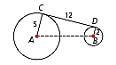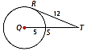

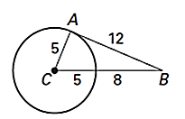

|  |  |  |  |
| --- | --- | --- | --- |
| **Name** | **Theorem** | **Hypothesis** | **Conclusion** |
| **Tangent Segments Theorem** | If two segments are tangent to a circle from the same external point, then the segments are congruent. |  |  |

**Example:** Find perimeter of triangle ABC. **Example:** Find DF if you know that DF and DE are tangent to.

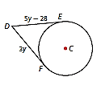

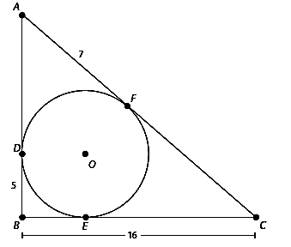

**Chord Properties**

|  |  |  |  |
| --- | --- | --- | --- |
| **Name** | **Theorem** | **Hypothesis** | **Conclusion** |
| **Congruent Angle-Congruent Chord Theorem** | Congruent central angles have congruent chords. |  |  |
| **Congruent Chord-Congruent Arc Theorem** | Congruent chords have congruent arcs. |  |  |
| **Congruent Arc-Congruent Angle Theorem** | Congruent arcs have congruent central angles. |  |  |

**Example:** Find the measure of arc HY and HYW.

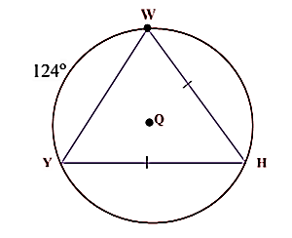

**Example:** Find the measure of angle DEF.

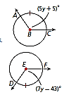

**Example:** Answer the following:

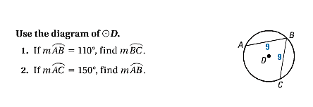

|  |  |  |  |
| --- | --- | --- | --- |
| **Name** | **Theorem** | **Hypothesis** | **Conclusion** |
| **Diameter-Chord Theorem** | If a radius or diameter is perpendicular to a chord, then it bisects the chord and its arc. |  |  |
| **Converse of Diameter-Chord Theorem** | If a segment is the perpendicular bisector of a chord, then it is the radius or diameter. |  |  |

**Example:** Find the measure of HT. Then find the **Example:** Find the measures of arc CB, BE, and CE.

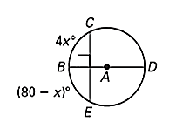measure of WA if you know XZ = 6.

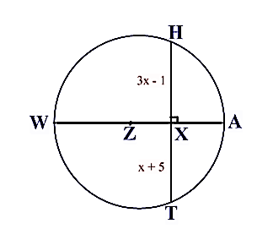

|  |  |  |  |
| --- | --- | --- | --- |
| **Name** | **Theorem** | **Hypothesis** | **Conclusion** |
| **Equidistant Chord Theorem** | If two chords are congruent, then they are equidistant from the center. |  |  |
| **Converse of Equidistant Chord Theorem** | If two chords are equidistant from the center, then the chords are congruent. |  |  |

**Example:** Find EF.

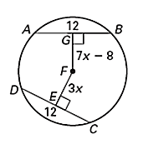

**Segment Lengths (In and Out of a Circle)**

|  |  |  |  |
| --- | --- | --- | --- |
| **Name** | **Theorem** | **Hypothesis** | **Conclusion** |
| **Segment Chord Theorem** | If two chords in a circle interest, then the product of the lengths of the segments of one chord is equal to the product of the lengths of the segments of the second chord. |  |  |

**Example:** Find x. **Example:** Find x.

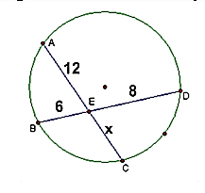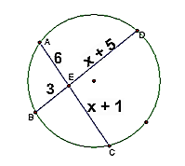

**Example:** Find x. **Example:** Find x.

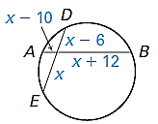 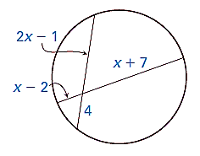

|  |  |  |  |
| --- | --- | --- | --- |
| **Secant Segment Theorem** | If two secant segments intersect in the exterior of a circle, then the product of the lengths of the secant segment and its external secant segment is equal to the product of the lengths of the second secant segment and its external secant segment. |  |  |

**Example:** Find x. **Example:** Find x.

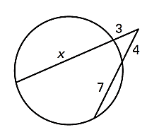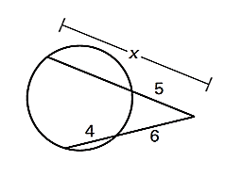

**Example:** Find x and then JF. **Example:** Find x.

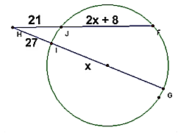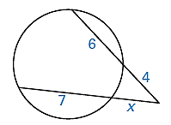

|  |  |  |  |
| --- | --- | --- | --- |
| **Secant Tangent Theorem** | If a tangent and secant intersect in the exterior of a circle, then the product of the lengths of the secant segment and its external secant segment is equal to the square of the length of the tangent segment. |  |  |

**Example:** Find x. **Example:** Find x.

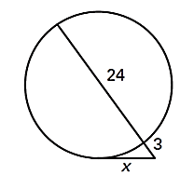 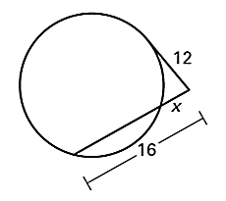

**Example:** Find x. **Example:** Find all possible values of x.

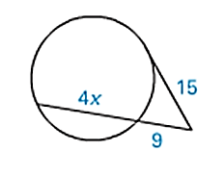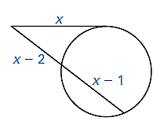

**Arc Length**

In 7th grade, you learned how to calculate the circumference of a circle. You also learned that the circumference of a circle divided by the diameter is equal to pi. The circumference of a circle is the distance around the circle.

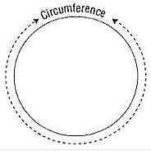

**Circumference**

C = 2r or C = d

Practice reviewing how to calculate the circumference or radius/diameter of a circle below. Leave your answers in terms of pi. Find the circumference, radius, or diameter.

A. r = 6 ft B. d = 15 in C. C = 16cm D. C = 40m

**Calculating Arc Length**

**Arc Length** is a fraction of the circle’s circumference and is measured in linear units. Arc length can be calculated using the following proportion:

**Arc Length**



**Example:** Find the length of arc BA.

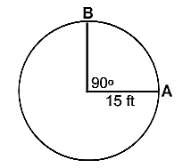

**Example:** Find the length of arc BC.

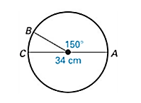

**Example:** Find the measure of arc AB.

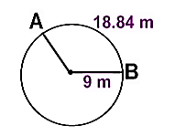

**Example:** Find the circumference of Circle Q.

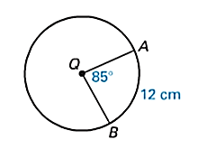

**Example:** Find the radius of Circle Q.

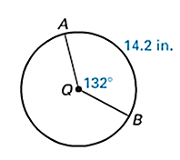

**Converting Radians and Degrees**

One unit of measurement for angles is degrees, which are based on a fraction of a circle. Another unit is called **radian**, which is defined as the measure of a central angle whose arc length is the same as the radius of the circle.

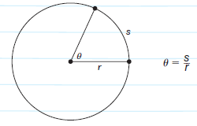

In the following picture, let *r* represent the length of the radius of the circle, θ represent the measure of the central angle in radians, and *s* represent the length of the intercepted arc. By the definition of radians, r and s are equal to each other. But what if I wanted to find the number of radians in the entire circle? I would have to take the circumference divided by the radius.

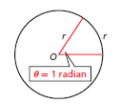

To convert from radians to degrees: To convert from degrees to radians:

**Example:** Convert from radians to degrees:



**Example:** Convert from degrees to radians

135 270 90

**Area of a Sector**

In 7th grade, you also learned how to calculate the area of a circle. The area of a circle is the number of square units inside the circle.

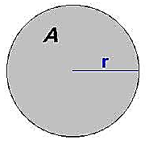

**Area**

A = r2

Practice reviewing how to calculate the area or radius/diameter of a circle below. Leave your answers in terms of pi. Find the area, radius, or diameter.

A. r = 6 ft B. d = 18 in C. A = 121in2 D. A = 16m2

**Calculating Area of a Sector**

A **sector** of a circle is a region bounded by two radii and their intercepted arc. **Area of a Sector** is a fraction of the circle’s area and is measured in linear units. Area of a sector can be calculated using the following proportion:

**Area of a Sector**



**Example:** Find the area of the shaded sector formed by angle PQR.

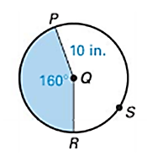

**Example:** Find the area of the shaded sector formed by the angle ACB.

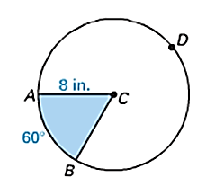

**Example:** Find the area of circle H.

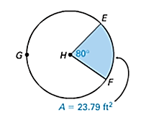

**Example:** Find the area of Circle H.

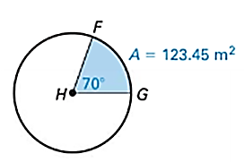

**Example:** Find the radius of Circle H.

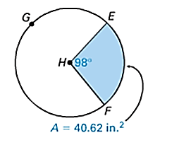

**Volume (Pyramids & Spheres)**

**Volume** is amount of space contained in an object or the number of unit cubes of a given size that will exactly fill the interior of a three dimensional figure. We will learn volume formulas for 4 different 3-D objects.

|  |  |  |  |
| --- | --- | --- | --- |
|  |  |  |  |
| **Cylinders**  *V=Bh*  where *B* is area of the base and *h* is the height  V= $πr^{2}h$ $πr^{2}$ represents the area of the base (circle) | **Pyramid**  *V=1/3Bh*  Where *B* is area of the base and *h* is the height  *Whatever shape the base is you will replace B with the formula for that shape. | **Cone**  *V=1/3Bh*  where *B* is area of the base and *h* is the height  V= $1/3πr^{2}h$ $πr^{2}$ represents the area of the base (circle) | **Sphere**  V=4/3 $πr^{3}$ Where r is the radius |

**Cavalieri’s Principle** states that if two three dimensional figures have the same height and the same cross sectional area at every level, they have the same volume. In other words, if two figures have the same dimensions (height, radii, base, etc), but are just slanted or oblique, they will have the same volume. Each of the figures above would have the same volume because they have the same height and cross section, even though they are slanted.

**Examples of two figures with the same volume:**

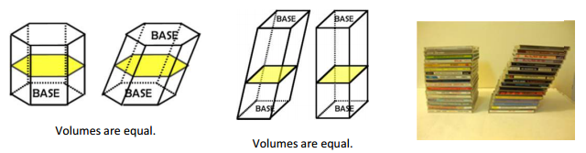

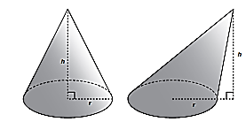 

**Volume of a Pyramid**

**Possible Base Formulas**

**Rectangle/Square:  Triangle: **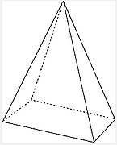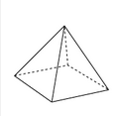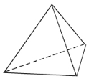

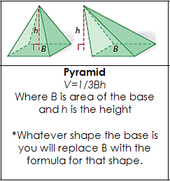

A. Find the volume of the following pyramids.

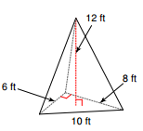 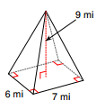 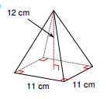

Find the height of a rectangular pyramid with a length 3 m, width 8 m, and a volume of 112 m3.

B.

C. The area of the base of a square pyramid is 7582 square feet. What is the length of the base?

**Volume of a Sphere**

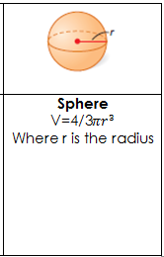

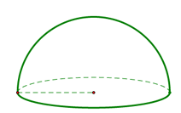

A **hemisphere** is half of a sphere. Its volume is half of a sphere’s volume.

A. Find the volume of the spheres. Write your answers exactly and approximately.

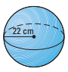 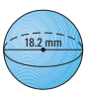 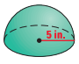

B. A rubber ball has a radius of 30 cm. What is the volume of the ball?

C. Find the diameter of a sphere with a D. Given that the volume of a sphere

volume of 972 in3. is 5276 cm3, find its radius.

**Volume (Cylinders & Cones)**

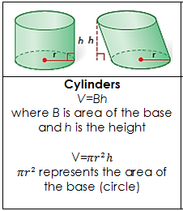

A. Find the volume. Write your answer exactly and approximately.

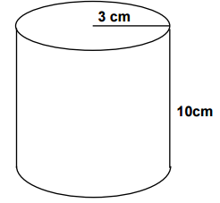 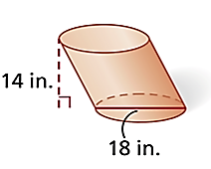

B. Solve for x.

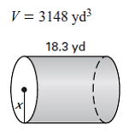 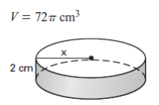

C. Find the volume of a cylinder with base area 121 cm2 and a height equal to twice the radius. Give your answer in terms of $π$ and rounded to the nearest tenth.

**Volume of a Cone**

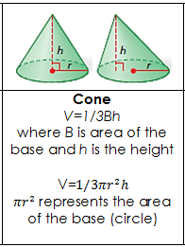

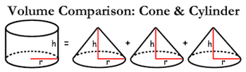

It takes 3 cones to fill 1 cylinder or 1 cone to fill 1/3 of a cylinder.

A. Find the volume of the cone. Write your final answers exactly and approximately.

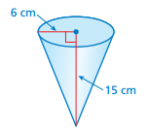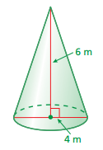

B. Find the missing dimension given the volume.

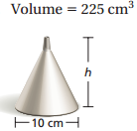 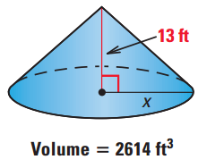

C. A cone just fits inside a cylinder with volume 300 cm3. What is the volume of the cone?

A cone has a volume of 150 cm3. What is the volume of a cylinder that just holds the cone?

D. Find the volume of a cone with base circumference 25 in. and a height 2 in. more than twice the radius.

**Application of Volume**

1. A standard size sheet of paper measures 8.5 inches by 11 inches. Use two standard sized sheets of paper to create two cylinders. One cylinder should have a height of 11 inches and the other cylinder should have a height of 8.5 inches. Predict which cylinder will have the greatest volume: _______________________________

a. Determine the radius of each cylinder:

h = 11 inches h = 8.5 inches

b. Calculate the volume of each cylinder.

H = 11 inches h = 8.5 inches

c. Does the radius or height have a greater impact on the magnitude of the volume? Why?

d. What does the radius need to be on the cylinder with a height of 11 inches so the volume of the cylinder with a height of 11 inches equals the volume of the cylinder with a height of 8 inches?