GSE Geometry HW Name:______________________________________

Transformations and Reflections Date:__________________________ Block:________

1. **Use the translation (x, y) 🡪 (x + 5, y – 9) $\left(x, y\right) → \left(x+5, y-9\right)$ for questions a-e.**
2. What is the image of A (-6, 3) $A(-6, 3)$?
3. What is the image of (4, 8) $(4, 8)$?
4. What is the image of (5, -3)?
5. What is the image of A’ from #1, which would be called A’’?
6. What is the pre-image of D’(12, 7) $D^{'}(12, 7)$?
7. **The vertices of $∆ABC$ are A(-6, -7), B(-3, -1), and C(-5, 2) $A\left(-6, -7\right);B(-3, -10)$ $C(-5, 2)$. Find the vertices of $∆A^{'}B^{'}C^{'}$, given the translation rules below.**
8. (x, y) 🡪 (x – 2, y – 7) $\left(x, y\right) → \left(x-2, y-7\right)$
9. (x, y) 🡪 (x + 11, y + 4) $\left(x, y\right) → \left(x+11, y+4\right)$
10. (x, y) 🡪 (x, y - 3) $\left(x, y\right) → \left(x, y-3\right)$
11. (x, y) 🡪 (x – 5, y + 8) $\left(x, y\right) → \left(x-5, y+8\right)$

**3. $∆A^{'}B^{'}C^{'}$ is the image of $∆ABC$. Write the translation rule.**

[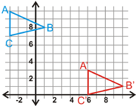](http://pilot.ck12.org/wiki/index.php/File:Geo-1202-08a.png)

[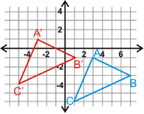](http://pilot.ck12.org/wiki/index.php/File:Geo-1202.08.png)

a. b.

[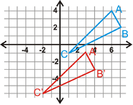](http://pilot.ck12.org/wiki/index.php/File:Geo-1202-09.png)

c. d.

[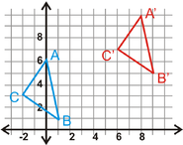](http://pilot.ck12.org/wiki/index.php/File:Geo-1202-09a.png)

**4. Find the line of reflection between the pre-image and the image.**

a. b. c.

[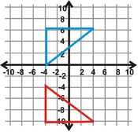](http://pilot.ck12.org/wiki/index.php/File:Geo-1203-16.png) [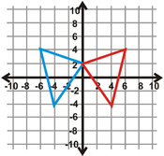](http://pilot.ck12.org/wiki/index.php/File:Geo-1203-16a.png) [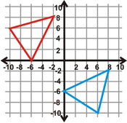](http://pilot.ck12.org/wiki/index.php/File:Geo-1203-16b.png)

**5. Two Reflections The vertices of $∆ABC$ are A(-5, 1), B(-3, 6), and C(2, 3). Use this information to answer questions a-d.**

1. Plot $∆ABC$**** on the coordinate plane.
2. Reflect $∆ABC$****over y =1 $y=1$. Find the coordinates of $∆A'B'C'$****.
3. Reflect $∆A'B'C'$**** over y = -3 $= -3$. Find the coordinates of $∆A''B''C''$****.
4. What one transformation would be the same as this double reflection?

**6. Two Reflections The vertices of $∆ABC$ are A(6, -2), B(8, -4), and C(3, -7). Use this information to answer questions a-d.**

1. Plot $∆ABC$**** on the coordinate plane.
2. Reflect $∆ABC$****over x = 2 $y=1$. Find the coordinates of $∆A'B'C'$****.
3. Reflect $∆A'B'C'$**** over x = -4 $= -3$. Find the coordinates of $∆A''B''C''$****.
4. What one transformation would be the same as this double reflection?