**Day 1 – Basics of Geometry Practice**

1. Interpret the following statements in words and then draw a picture:

a.  b.  c. 

2. Name the following:

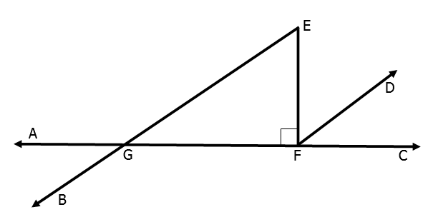a) a linear pair ____________ ____________

b) a pair of supplementary angles ____________ ____________

c) a pair of complementary angles ____________ ____________

d) a pair of vertical angles ____________ ____________

e) two right angles ____________ ____________

3. Identify the types of angles relationships shown. Then find the measure of the missing angle.

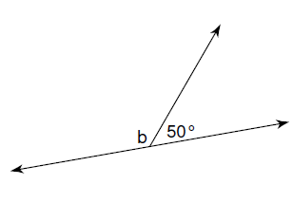a. b. c.

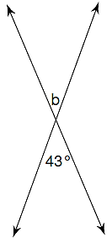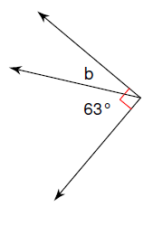

4. Linear pairs could be defined as being supplementary angles because they always add up to 180º. Are all supplementary angles also linear pairs? Explain.

5. Find the angle measures of x, y, and z. 6. Solve for x.

130ᵒ

xᵒ

yᵒ

zᵒ

2x

x + 30

7. Suppose that mA = 66, B is complementary to A, and C is supplementary to B. What are the measures of angles B and C?

8. The variables x and y in the figure represent the measures of angles. Solve for x and y.

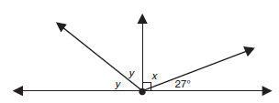

9) Find each of the following:



1. x
2. m∠LAT
3. m∠TAO

d) m∠PAO

10. Find the value of x. 11. Find the 

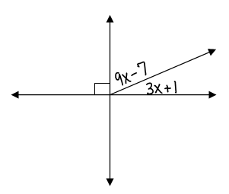 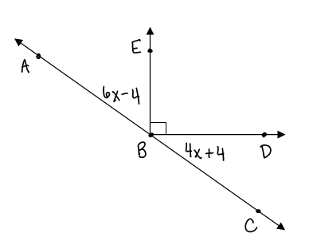

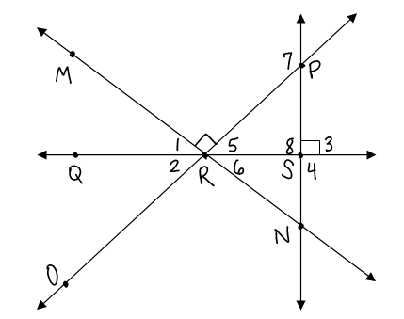

12. *True or False?*

a. ∠PRN is acute.

b. ∠4∠8

c. m∠5 + m∠6 = 90

d. 

e. ∠7 is obtuse