GSE Geometry Name:___________________________________
Date:_______________________ Block:______
Unit 2 Review: Transformations & Congruence
Learning Target #1: Rigid Transformations
Find the coordinates of the vertices of each figure after the given transformation.
1. Reflection across y = -x 2. (x, y) (x + 4, y – 3)
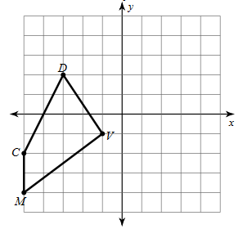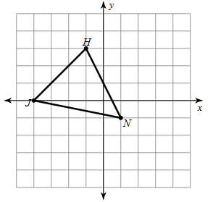
3. Rotation 90º counter clockwise 4. Reflection across y = -1
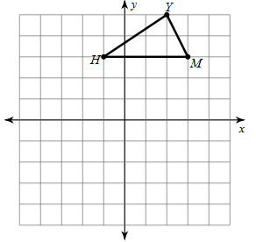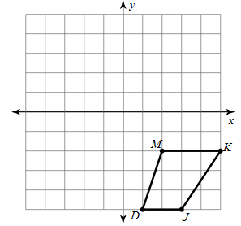

Write a rule to describe each transformation.
5. D(-2, -2), I(-3, 0), S(1, 0), W(3, -4) 6. I(-4, 2), W(-4, 3), L(-1, 4), G(0, -1)
D’(2, 2), I’(3, 0), S’(-1, 0), W’(-3, 4) I’(4, 2), W’(4, 3), L’(1, 4), G’(0, -1)

7. X(-3, -1) 8. N(1, 4), W(1, 5), Q(3, 5)
X’(5, -1) N’(-1, -2), W’(-1, -1), Q(1, -1)

Learning Target #2: Congruent Triangles & Proofs
Complete each congruence statement by naming the corresponding angle or side.
9. $∆LKJ≅∆LBC$ 10. $∆VWX≅∆VIJ$ 11. $∆KLM≅∆LKC$

$∠JLK≅__________$ $\overline{WX}≅__________$ $∠M≅__________$

State if the two triangles are congruent. If they are, state how you know.
12. 13. 14.
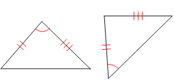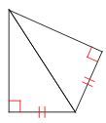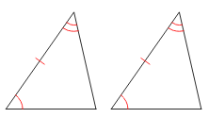

15. 16. 17.
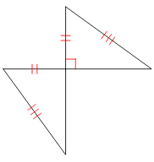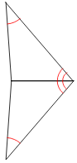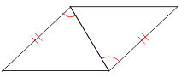

State what additional information is required in order to know that the triangles are congruent for the reason given.
18. ASA 19. SSS 20. HL
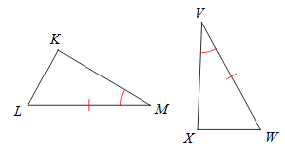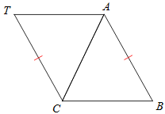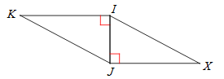

Complete the proofs.
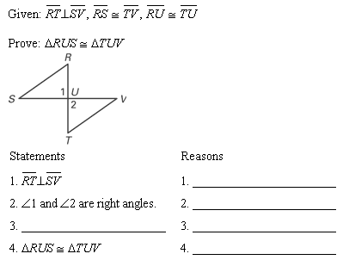
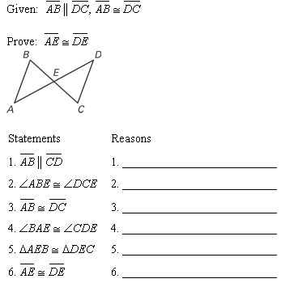
21. 22.

Learning Target #3: Triangle Relationships
Solve for x.
23. 24. 25.
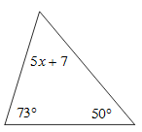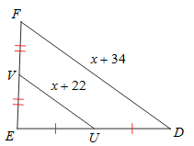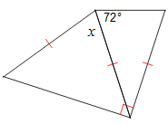

26. 27. 28.
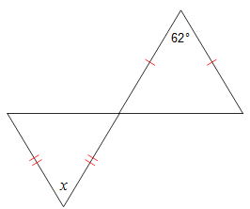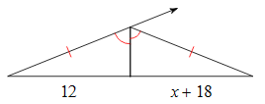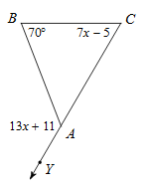
Solve for the indicated measure.
29. $m∠$EDC 30. $\overline{DE}$ 31.$m∠$2
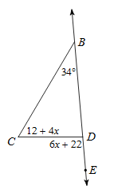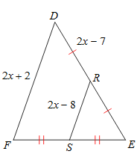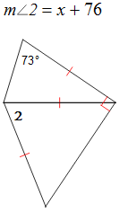

32. Determine if the following side lengths could form a triangle.
a. 9, 7, 13 b. 15, 1, 15 c. 9, 2. 5 d. 81, 94, 184

33. Triangle STU has the following side lengths: $\overline{TU}=19, \overline{SU}=25, \& \overline{ST}=15$. Order the angles in the triangle from smallest to largest.

34. Triangle MLK has the following angle measurements: $m∠M=64°, m∠L=48°, \& m∠K=68°$. Name the largest and smallest side in each triangle.

Learning Target #4: Parallelograms
Solve for x. Each figure is a parallelogram.
35. 36. 37.
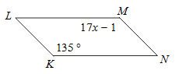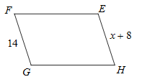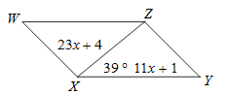

Solve for x.
38. 39. 40.
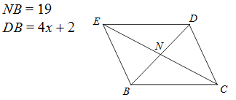
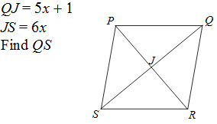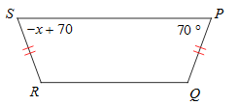
Rule Practice:
41. What is a rule for 90 degree clockwise rotation?
42. What is the rule for 180 degree rotation?
43. What is the rule for a translation up 6 and right 4?
44. What is the rule for a 270 degree clockwise rotation?
45. What is the rule for a reflection over y=x?
46. What is the rule for a reflection over the y-axis?
47. What is the rule for a reflection over y=-x?
48. What is the rule for a reflection over the x-axis?
Find the Value of n:
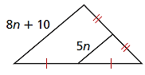
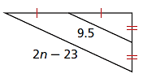
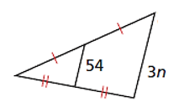
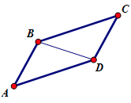
Given: ABCD is a parallelogram

Prove: $\text{∠}\text{A }\text{≅} \text{∠}\text{C}$

Statements | Reasons
 | - Given
- $\overline{\text{AB}} \text{∥} \overline{\text{CD}}$, $\overline{\text{AD}} \text{∥} \overline{\text{CB}}$ | - Definition of a parallelogram
 | 3) Alternate Interior Angles are congruent
4)$\text{ ∠}\text{ADB }\text{≅} \text{∠}\text{CBD}$ | 4)
5)$\overline{\text{BD} } \text{≅} \overline{\text{BD}}$ | 5)
6) | 6)
7) | 7) CPCTC

