Learning Card # ______ | Name:
Facts!  Translations are ____________ transformations.  Meaning, the ________ and __________ are not  affected, only the ______________. |  | Notation:  $$(x±a, y ±b)$$
Example:  The quadrilateral ABCD is translated up 5 and left 3.  A(-1, 3) B(2, -1) C(5, 4) D(-5, -7).  State A’B’C’D’ |  | 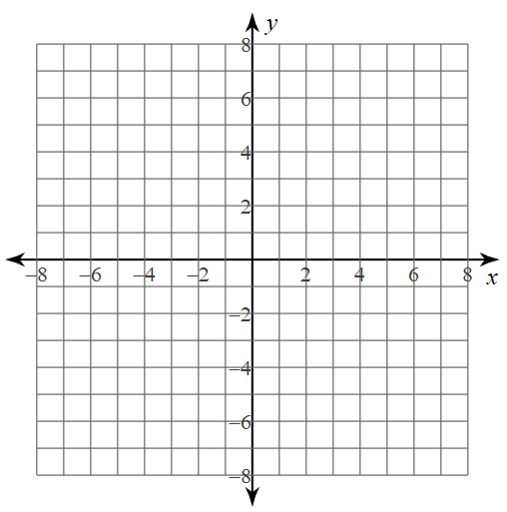  A (2, 5)  B (-3, 6)  C (5, -2)  Graph the  image if it was translated  (x + 2, y + 3)
Translations

Learning Card # ______ | Name:
Facts!  Reflections are the __________ distance from the  “_______________”. |  | X-axis Y-axis  Reflect A(-2, 3) B(4,1) C(0, -5)
$y=x$ $y=-x$  Reflect A(-2, 3) B(4,1) C(0, -5) |  | Horizontal and Vertical Lines  Y =  X =
Reflections
Learning Card # ______ | Name:
Facts!  Rotating 180 is the ______________ no matter which direction.  Rotating 90 _______________ is the same as  270 _________________  Rotating 90 ________________ is the same as  270 ___________________ |  | RULES!  180 90 CW 90CCW
Rotate A(-2, 3) B(4,1) C(0, -5)  180 270 CW |  | Graph and rotate 90 CW  A(3, 6) B(1, -5) C(-2, 0)
Rotations

