Learning Card # ______ | Name:
Lines, line segments, or rays that _____________  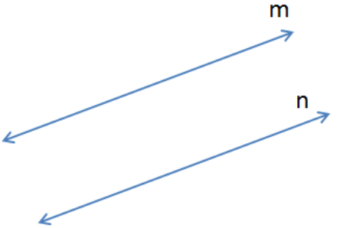  _______________. |  | A ___________________ is a line that cuts through parallel lines.  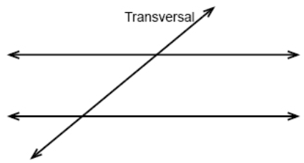
Parallel Lines

Learning Card # ______ | Name:
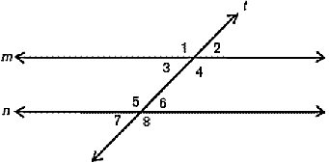  Definition:  Two angles in the __________________ of the parallel lines and on __________________ sides. |  | Solve for x:  ∠ABC and ∠XYZ are interior angles.  ∠ABC = 6x – 23  ∠XYZ = 3x + 4
Alternate Interior Angles

Learning Card # ______ | Name:
Definition:  Two angles in the __________________ of the parallel lines and on __________________ sides. |  | ∠ABC and ∠XYZ are exterior angles.  ∠ABC = 14x + 8  ∠XYZ = 4x + 28
Alternate Exterior Angles

Learning Card # ______ | Name:
Definition:  Two angles in the __________________ of the parallel lines and on __________________ sides. |  | ∠ABC and ∠XYZ are same side interior angles.  ∠ABC = 5x + 4  ∠XYZ = 10x + 11
Consecutive (Same-Side) Interior Angles

Learning Card # ______ | Name:
Definition:  Two angles in the __________________ of the parallel lines and on __________________ sides. |  | ∠ABC and ∠XYZ are same side exterior angles.  ∠ABC = 4x + 23  ∠XYZ = 2x + 37
Consecutive (Same-Side) Exterior Angles

Learning Card # ______ | Name:
Definition:  Two angles that lie in the_______________________________. |  | ∠ABC and ∠XYZ are corresponding angles.  ∠ABC = 2x - 5  ∠XYZ = 3x - 10
Corresponding Angles

