Learning Card # ______ | Name:
A line, line segment, or ray that intersects at the  _____________of a line segment at a _____ degree angle. |  | 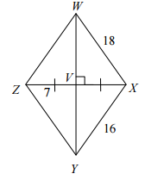  Is $\overline{WY}$ a perpendicular bisector?  Explain.
$\overline{GH}$ is the perpendicular bisector of $\overline{LM}$.
Solve for x and y.
8y + 3
15y + 10
$$3x-24$$

Perpendicular Bisector

