Learning Card # ______ | Name:
Point that _____________ the segment into _____  _______________ segments.  This is similar to an __________ ________________.  Midpoint drawing: |  | Find $\overline{FM}$ and $\overline{MG}$  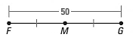
Find $\overline{YM}$ and $\overline{YZ}$  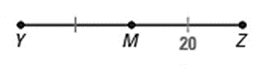 |  | T is the midpoint of $\overline{QR}$. Solve for x.  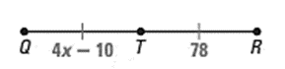
Midpoint

