Learning Card # ______ | Name:
________ + ________ = __________  ________ + ________ = __________  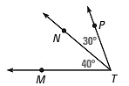 |  | 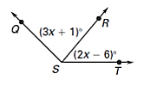  ________ + ________ = __________  ________ + ________ = __________
Practice:  Draw and solve  $$∠ABC=100°$$  $$∠ABD=3x-5$$  $$∠DBC=5x+9$$ |  | Practice:  Draw and solve  $$∠XYZ=136°$$  $$∠XYA=4x+10$$  $$∠AYZ=-35-3x$$
Angle Addition

