Keeper #6: Circles and Ellipses

Standard Equation: Standard Equation:

Main parts of a circle: Main parts of an ellipse:

Write the standard form for the circle Write the standard form for the ellipse
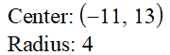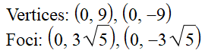

Write the general form for the circle
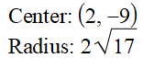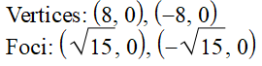

Label all main parts of the conics
